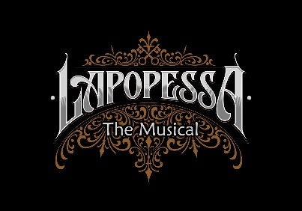
LAPOPESSA THE MUSICAL CONCERT

TALENT RELEASE FORM

I, the undersigned, enter into this Agreement with Paul N. Dion and Allen M. Dion, herein referred to as Producer. I have been informed and understand that Producer is producing a video program and that my name, likeness, image, voice, appearance and/or performance is being recorded and photographed and made a part of that production ("Product"). The Product includes any and all auditions, rehearsals, and performances of Lapopessa the Musical Concert.
1. I grant Producer and its designees the right to use my name, likeness, image, voice, appearance, and performance as embodied in the Product whether recorded on or transferred to videotape, video files, film, slides, photographs, audio tapes, or other media, now known or later developed. This grant includes without limitation the right to edit, mix or duplicate and to use or re-use the Product In whole or part as Producer may elect. Producer or its designee shall have complete ownership of the Product in which I appear, including copyright interests, and I acknowledge that I have no interest or ownership in the Product or its copyright.
2. I also grant Producer and its designees the right to broadcast, exhibit, market, sell and otherwise distribute the Product, either in whole or in parts, and either alone or with other products, for commercial or non-commercial television or theater, closed-circuit exhibition, home video, websites, promotional materials, or distribution or any other purpose that Producer or its designees in their sole discretion may determine. This grant includes the right to use the Product for promoting or publicizing any of the uses.
3. I confirm that I have the right to enter into this Agreement, that I am not restricted by any
commitments to their parties, and that Producer has no financial commitment or obligations to me as a result of this Agreement. I hereby give all clearances, copyright and otherwise, for use of my
name likeness, image, voice, appearance and performance embodied in the Product. I expressly
release and indemnify Producer and its officers, employees, agents and designees from any and all claims known and unknown arising out of or in any way connected with the above granted uses and representations. The rights granted Producer herein are perpetual and worldwide.
4. In consideration of all the above, I hereby acknowledge receipt of reasonable and fair
consideration from the Producer.
I have read the foregoing and understand its terms and stipulations and agree to all of them:
Talent Name (Please Print) ____________________________________________________
Signature ________________________________________________ Date _____________

